Azure Assignment

(AZ – 104- Module 2)

Avishekh Sinha

# Module 2

## Assignment 1

Create 2 resource groups rg-1 and rg-2

|  |  |
| --- | --- |
|  |  |

2.Add storage account to rg-1

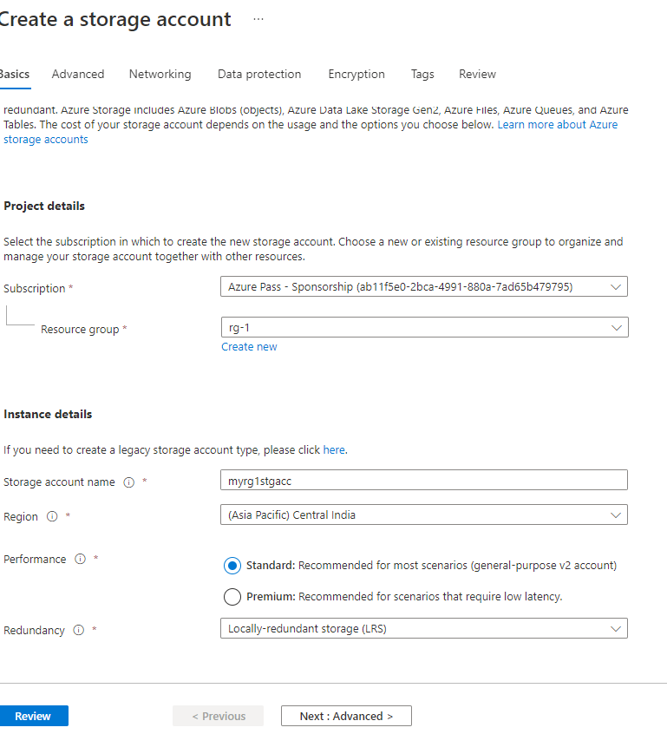

3. Move storage account from rg-1 to rg-2

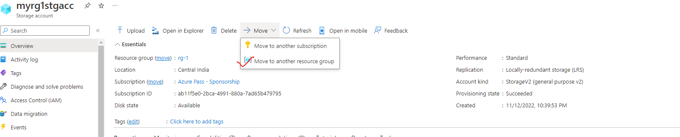

## Assignment 2

1. Create 3 storage accounts with “Team” tags: team1, team2 and team3 respectively

|  |  |
| --- | --- |
|  |  |
|  |  |

2. Create one more storage account for team2

3. List all resources for team2 using tags

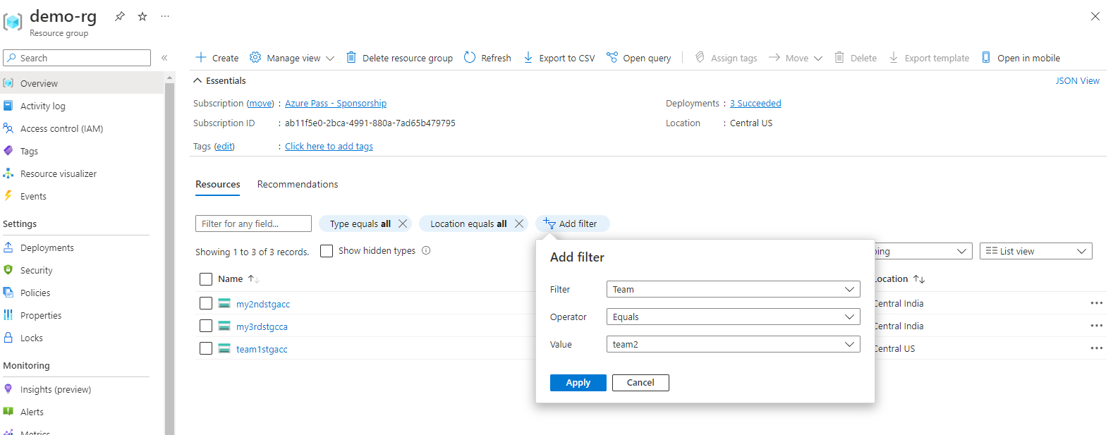

## Assignment 3

1. Create a File share in Azure Storage

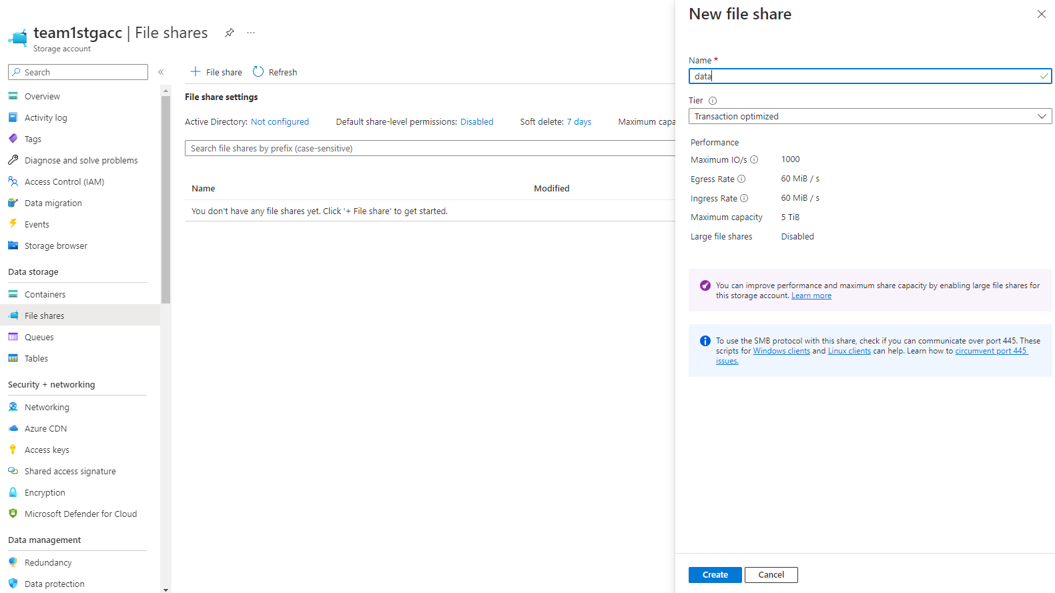

1. Mount this file share on windows and linux

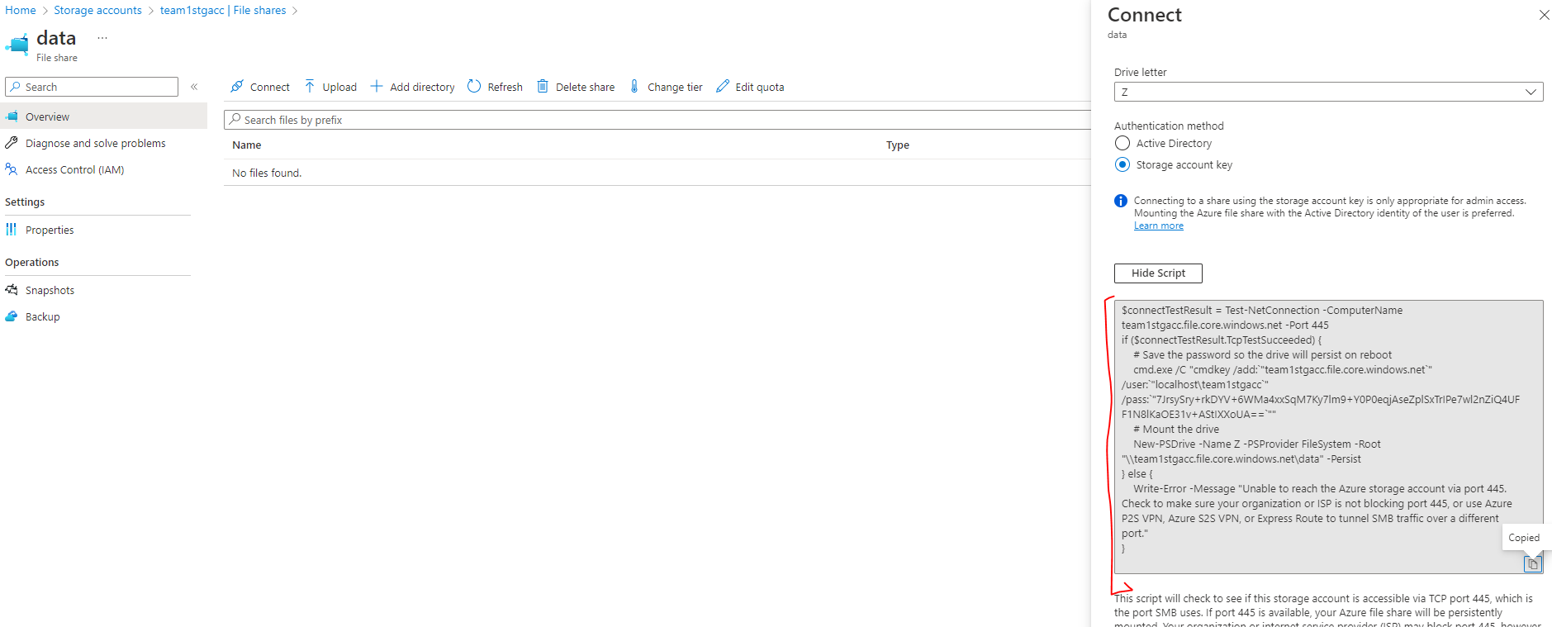

## Assignment 4

1. Create a Storage account, and upload some files in Blob storage

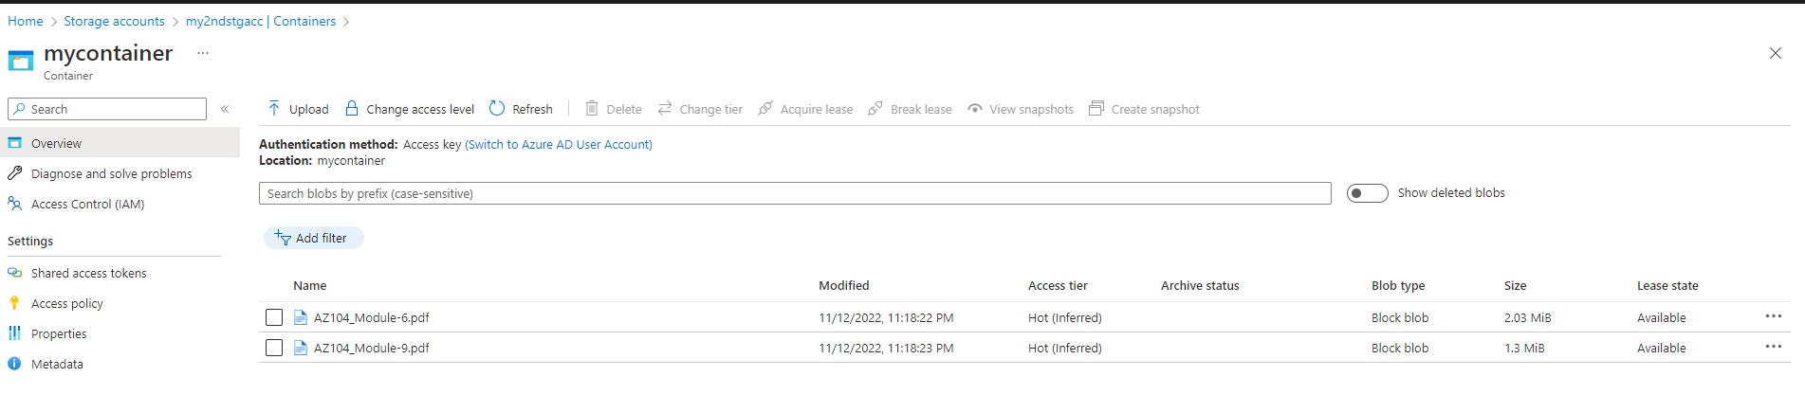

1. Create a CDN profile

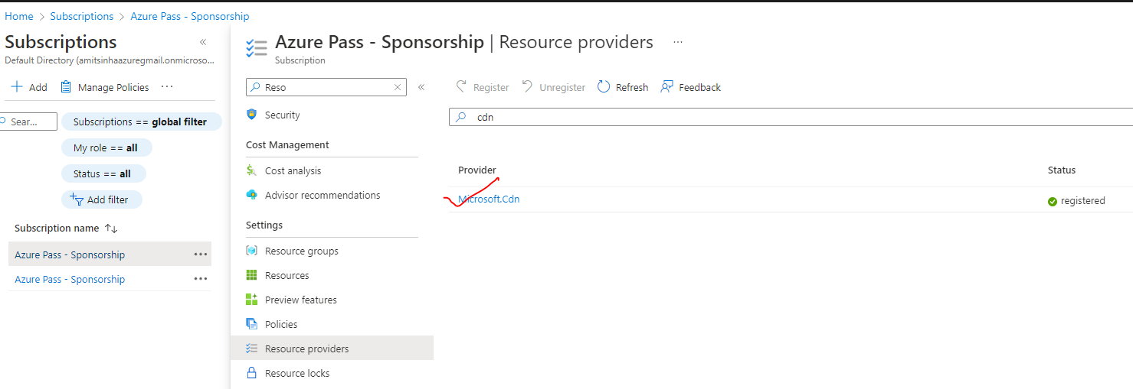

3. Create an endpoint and connect to the Azure blob to access the files uploaded

## Assignment 5

1. Create a storage account

2. Use the blob service and upload some files in it

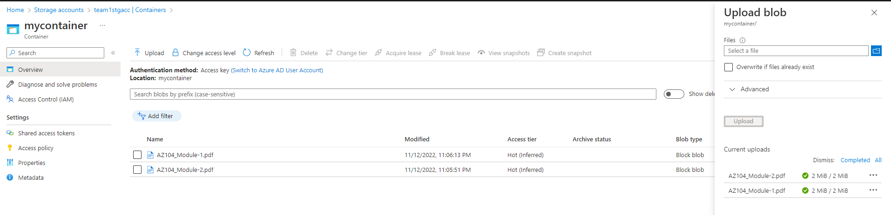

1. Change the access tier to archive

